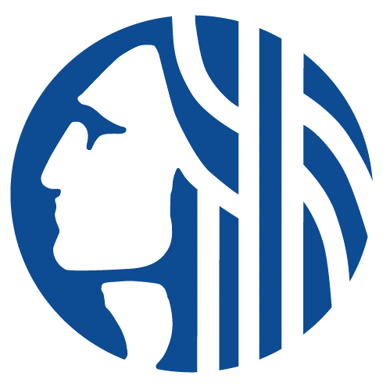

CENTRAL WATERFRONT OVERSIGHT COMMITTEE
Wednesday March 6th, 2024
11:30am-1:00pm
In person: Mithun – Orca Room
Virtual: Teams info below
Agenda
- Welcome
- Construction Timelines to Park Opening!
- CWOC recruitment
- Annual Report
- Performance Standard – Q1 Park Inspection
  - ArcSurvey
  - Training Dates
  - Timeframe

Teams Meeting Info: Join on your computer, mobile app or room device
Click here to join the meeting
Meeting ID: 299 520 373 034
Passcode: ib2rjv
Download Teams | Join on the web
Join with a video conferencing device
seattle@m.webex.com
Video Conference ID: 118 189 542 4
Alternate VTC instructions
Or call in (audio only)
+1 206-686-8357,,22596611# United States, Seattle
Phone Conference ID: 225 966 11#

